**Steps to Login to your WAWA account**

**Prerequisites**:

1. An email from AIMTEAM with Subject “Secure Messaging Password Notification” is sent to each user on HCL mail-id.

**Step 1:**

* In the mail, login information (username and temporary password) is shared by Wawa.
* In the mail, there will be a hyperlink asking the user to click to proceed to Secure messaging service. Click on it and it will direct to the below URL:

<https://wawa.login-us.mimecast.com/u/login/?gta=secure#/login>

* Once the URL is hit, enter the login information and it will ask to reset the password.
* Once the password is reset successfully, user is taken to WAWA inbox.
* A mail from AIM Team will be present in the mailbox which will have details of user’s **WAWA username and WAWA Person id.**
* Make a note of WAWA username and Person id

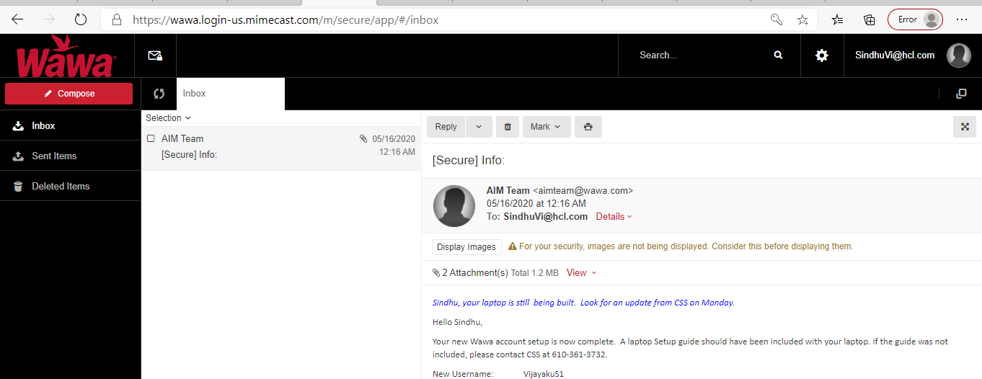

**Step 2:**

* On mobile device (Android or IOS), please download the below two applications from the Play store/App store:
  + Hangouts Dialer
  + VIP access

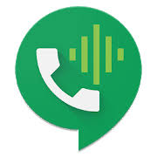

* From the Hangout Dialer, call the **Wawa** **CSS team +1-610-361-3732** through an active Wi-Fi or mobile data connection.
* Share your WAWA username with CSS team, and ask them to reset the password. Ensure to mention them that you are using a non-WAWA laptop and request them to provide the password on the call. They will be providing a password on the call which you may have to note it down.
* In the same call, mention them that your WAWA id must be linked with the serial number of the VIP access application (this system is like an authenticator application which you may need while switching between various applications inside the Citrix environment. You may have to enter the token generated on the application in order to proceed through navigating around Citrix).
* Open the VIP Access application on your phone and make a note of the 8-digit serial number displayed on the top with prefix **SYMC xxxx xxxx**. Mention this serial number to the support team to link it your WAWA account.

**Step 3 (Only for DATA track members):**

Pre requisite:

* The host file entry required for the Citrix setup must have been completed
* The laptop must be connected to the required VPN connection
* Logon to <https://workspace.wawa.com/logon/LogonPoint/tmindex.html>

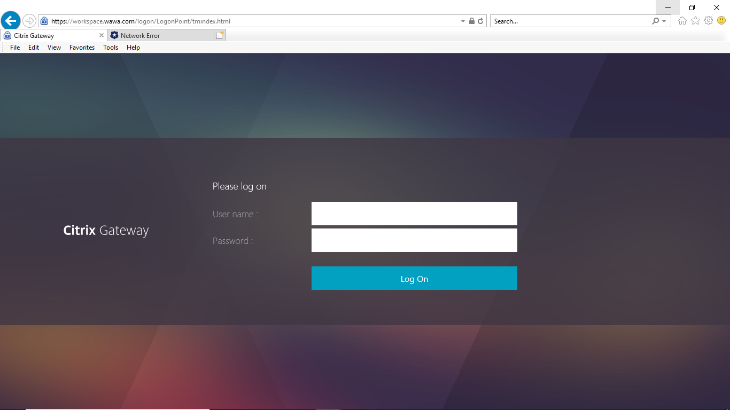

* Enter your WAWA username and the password you obtained from the support team and tap on Log on button. Upon successful authentication of the credentials the next screen will ask you to download the Citrix Receiver. Upon downloading of the same you must be able to successfully login into Citrix and access the applications.

Note: It may ask a passcode after entering your WAWA username and password, you have to enter the token generated in the VIP access application on your mobile.

